**An Investigation into How Movie Ratings Vary Following a Movie’s Release**

TEAM 11 | CITADEL DATA OPEN WEST COAST REGIONAL

**Summary of Insights**

>The monthly average ratings of a movie tends to decrease

BACKGROUND

MODEL 1: HOW DO MONTHLY AVERAGE RATINGS DEPEND ON TIME AFTER RELEASE AND CONSUMER PROFILE?

Consumers read product ratings and reviews all the time to make informed consumption decisions. As the film industry enters a Second Golden Age with the emergence of streaming giants, movie ratings are playing an increasingly prominent role in consumer choice. Nevertheless, these ratings are inherently inconsistent across reviewers. In particular, More importantly. How might we better understand the evolution of consumers’ perception of a movie following its release?

>**MODEL**

We ran a multilinear regression model for movies released during and after 1996 using the following equation.

*yt* = *β*0 + *β*1*x*1 + *β*2*x*2 + *εi*

*yt*

monthly mean rating of a specific movie

>**OUTCOME**

t

n

u

o

c

e

i

v

o

M

*β*1 Distribution *β*2 Distribution 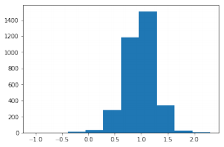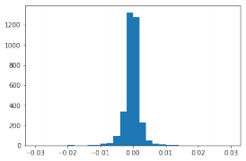

t

n

u

o

c

e

i

v

o

M

>**DISCUSSION**

Both of our predictors have high statistical significance across our movies dataset. In particular, the

*x*1

number of months since the movie was first rated *x*2

mean user rating (across all movies rated by each user) across users who rated the movie in the given month

Coefficient value

For the impact of time elapsed since movie release, there is an almost even split on the

Coefficient value

For the impact of user rating profile, the coefficient is generally positive, suggesting

**Motivation**

While one would presume most consumers tend to watch movies within a year or two after its release,

t

we found that a bulk of consumers

n

u

o

actually continue watching movies

c

g

n

i

Rating Count After Movie Release Date 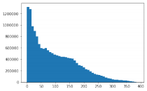

In short, we are using time elapsed and overall user rating behavior (predictors) to predict a movie’s monthly ratings.

direction of this impact, with a slightly negative skew, suggesting that monthly ratings decrease slightly over time. This distribution also suggests that impact may vary across movies.

that the rating of most movies are in line with people’s expectations. We can also see that there is an uneven distribution near 1.0, suggests

many years after (right). These

t

a

R

distributions also seem to vary

across genres (bottom).

Months after movie release

MODEL 2: DO MOVIE FEATURES DETERMINE THEIR RATING TRENDS OVER TIME?

>**MODEL**

*Hidden Decision*

>**DISCUSSION**

**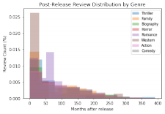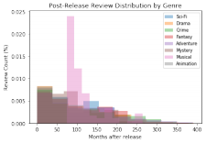***Movie Features* DATA

**Features for ~60,000 Movies**

Industry metadata such as genre, budget, profit margin,

runtime, year released

*Layers Rating Trends 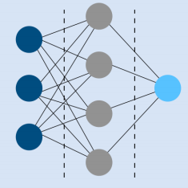*

Based on the insights from the first model, we decided to further investigate the impact of time elapsed on monthly movie ratings, this time emphasizing the movie features as a predictor for the monthly rating trends over time.

We selected two particular characteristics in evaluating rating trends over time:

>Total variance in ratings over time

insulated against random noise

>Net rating change (magnitude and direction) over a specific time period

>E.g. This is a movie

Using the various features for our movies, we ran a neural network in an attempt to predict the rating trends based on movie features.

>**OUTCOME**

**~28,000,000 User Rating Data from MovieLens** Unique user ratings for movies with timestamp

**1,128 “Genome Tags” for ~13,000 Movies** Each tag-movie pair has a relevance score based on user feedback

Simplified illustration of our artificial neural network, which we use to predict monthly rating trends using movie features

with high variability (compare blue and black lines) and negative net rating change (red line).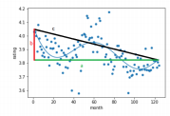

**- Trend** Movie